

**CSR Auto Booking Playbook**

***When customers call for help, we are here to make them feel Glass Doctor will take care of them. By setting up their work orders/quotes, asking clarifying questions, and taking an efficient path to solving problems, this script is the backbone of our customer service process.***

***\*Following all verbiage exactly is not required, however, there are areas where mandatory verbiage is labeled with* LARGE BOLD INDICATORS*.***

**Service Titan – CSR AUTO QUOTES CALL SCRIPT:**  
  
**1. Power Greeting:** ***"Glass Doctor, we fix your panes! This is _____!"***

* Start your call with high energy and a confident voice!

**2. Estimating Cost (VIN):** *"I’ll let you know that you’re probably looking at $x-$x minimum. If you have your VIN # available, I can give you an exact price. Do you happen to have that available?"*

Windshield: $300-$500 Min.

Windshield+ calibration (Static: IN-SHOP ONLY; Dynamic: Mobile home/work address) : $700-$900 Min.

Door glass part: $300-$500 Min.

3-piece assembly: $800-$900 Min.

Regulator: $300-$500

Chip repair: $150/ $25 for every additional chip 90 in shop

**3. If Customer Does Not Have VIN #:**  
*"No problem! Let me go ahead and send you a text message. Whenever you find that VIN number, you can text it to us, and I can start building that quote out for you."*

**3-a. If Customer Has VIN #:**  
*"Perfect! You can go ahead and read that off for me whenever you’re ready."*

* *[Wait for VIN number to be provided]*

**4. Move to Customer Info Grab:**  
***"Let me go ahead and get your information and then I can work on building this quote out for you. What was your first and last name?”*** *(Confirm cellphone number)*

**5. Confirm Quote Building:**  
*"This will just take me a few moments to build this quote out and make sure the part is available."*

*[Pause and proceed with quoting]*

**6. Fix customer/Show empathy! Ask About Damage Cause:**  
***"How did this damage happen, if you don’t mind me asking?"***

***“Is the glass itself broken?”***

**7. Windshield Protection Plan Information:**  
*"This does come with our Windshield Protection Plan, which covers the cost of any rock chips in the first 12 months post-installation from any road hazard damage. If an additional replacement is needed, we’ll cover the cost of the glass."*

**8. Quote Summary:** ***"Your total for the replacement, parts, tax, labor, everything included, came out to $[X]."***

**8-a. If Customer hesitates”** *“if you put a deposit with us before we close today, I can offer you a price at $x. We do close today at 4:30 today” or*

*"If you can bring the vehicle to one of our shop locations, I will drop that total down to (insert discounted price)!"*

**9. Payment and Deposit Information:** ***"To get you on our schedule and to guarantee your appointment we do require a $100 deposit. The remainder would be collected upon completion of the work."***

*(50% Deposit of total amount for chip repair)*

**10. VERBIAGE MOST IMPORTANT! Ask About Timing:** ***"When do you need this done?"***

*Check Auto-Scheduling Slack for updated dates -* ***“We are scheduling for __day or any day after, what hours can you be available?”***

* ***Remember: We CANNOT provide an exact time for mobile service. Be sure to ask what time the customer needs the job done after/before****.*

**11. Closing Statement:** ***"Okay the day before you will receive a text confirmation with a tighter timeframe of arrival. I am going to send you a text message here shortly that will just ask you to take a picture of that glass from the outside of the vehicle for part verification. “***

***“Did you have any other questions for me?”***

***“Thank you for choosing Glass Doctor!”***

**11-a. If Customer hesitates:** *"Okay, I'll go ahead and email this estimate over to you, and I will also send you a text message at this ### number with my information. If you have any questions, you can always text back in that text thread or give me a call and I can answer those questions for you. Again, my name is ____ with Glass Doctor”*

1. *Get customer information/ Often times putting Carrollton address as a placeholder to get customer quote as quickly as possible.* ***Be sure to go back after giving the quote to update the address on file****!*A screenshot of a computer

   AI-generated content may be incorrect.
2. *Collect the vin # in Autobolt tab/ confirm correct vehicle with cx. This will also give you the correct part # for Windshield replacements*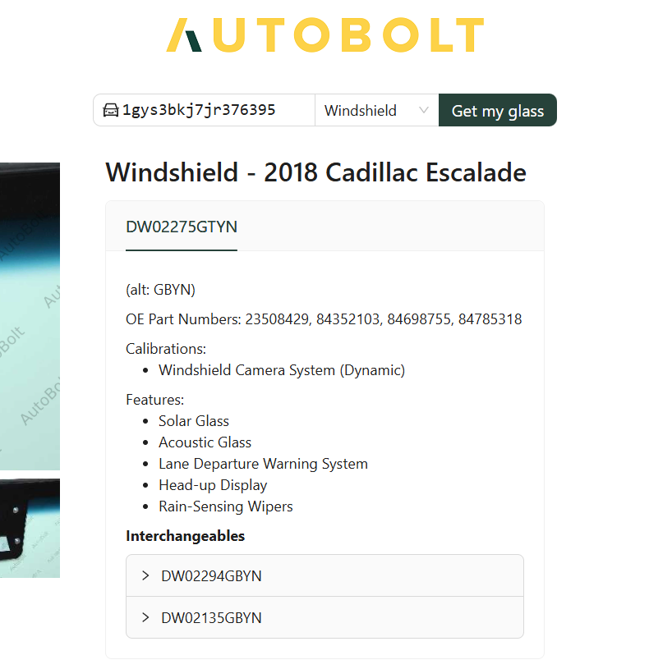



1. *Select Build estimate*

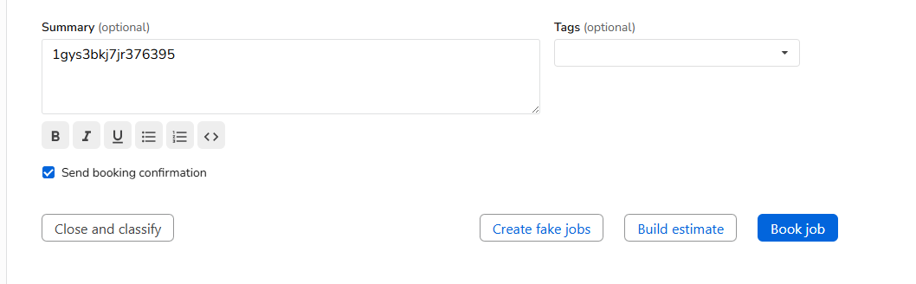



*4.) Name: Enter the type of work we will be doing   
5.) Business Unit: Auto Glass  
6.) Summary: Vin #*

*7.) Click Create  
8.) Click on Auto Builder  
*



*  
10.) Insert Vin # Provided by customer and click search*



*11.) Select the correct Glass Type*

*  
  
  
  
11-B.) In some cases you will need to further identify the exact vehicle type (Example Below)  
  
11-B.) In order to identify the correct vehicle, enter the vin # into PGW and select the correct Vehicle in ST  
  
  
11 -C.) In some cases you need to further answer the questions in ST to identify the correct part (ex. Door glass, Vent glass, etc.) *see below* For Windshield replacement you can select glass replacement and skip questions *for chip-repairs click Chip repair and add to estimate*  
  
11 -C.) Moving to the glass Tab on the left of the screen/ Select the correct part # for the door glass   
  
  
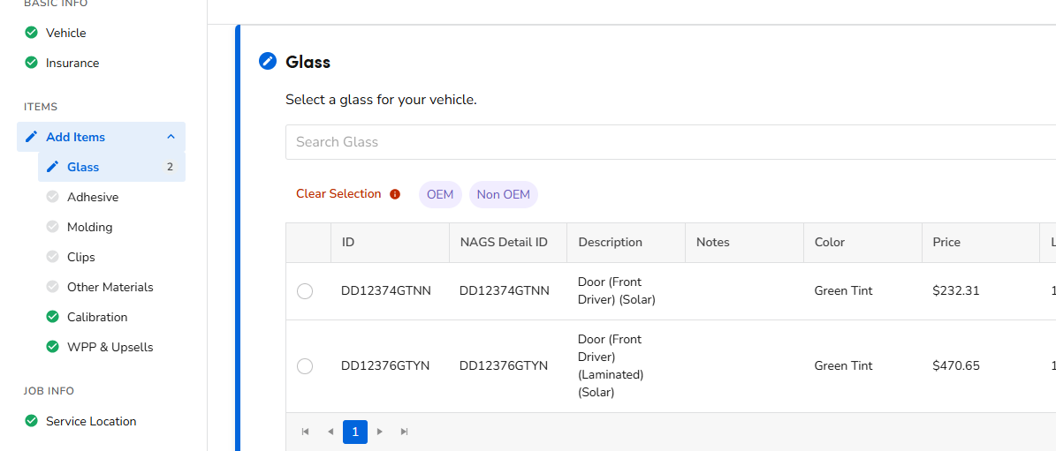  
  
  
12.) Copy the part # (from either auto bolt or ST) And paste into MyGrant or PGW  
13.) Make sure this is Available and check the price  
  
  
14.) For windshield replacements, Enter that Part # Into ST to select the correct part and click Next  
  
  
  
  
  
  
15.) Select the correct vendor by Matching the price with Mygrant or PGW and click save  
  
16.) Moving to the Adhesive tab on the left. Select The fast cure option and click save (door glass does not require adhesive)  
  
  
  
  
  
  
  
  
  
  
  
  
  
  
17.) Moving to the Calibration Tab on the left. Select the correct calibration if any is required and hit save. You can find this information from autobolt. * see below*  
  
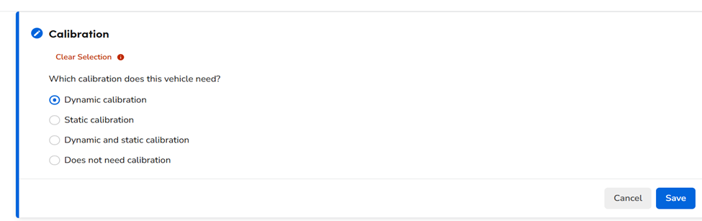  
  
18.) Moving to the WPP Tab on the left of the screen. For windshields only – Select qualify. Anything else does not qualify. *Ignore the upsells on the right of the screen*  
19.) Moving to the service location tab on the left. Click Mobile and click the cx address or Carrollton if you have not received it yet. If the work is being performed in shop select this for now  
  
20.) Click add to estimate  
  
  
  
  
  
21.) If The work is being performed in shop, Click on Cx billing information name and click add location   
 *Vehicles that require Static calibration must always be performed in shop*  
  
  
  
  
  
  
  
  
  
  
  
  
  
  
  
  
  
21- B.) Create the new location as *Cx Name* *Location*.  
21 -B.) Add the Shop address and Cx phone #  
21 -B.) Click create Location  
  
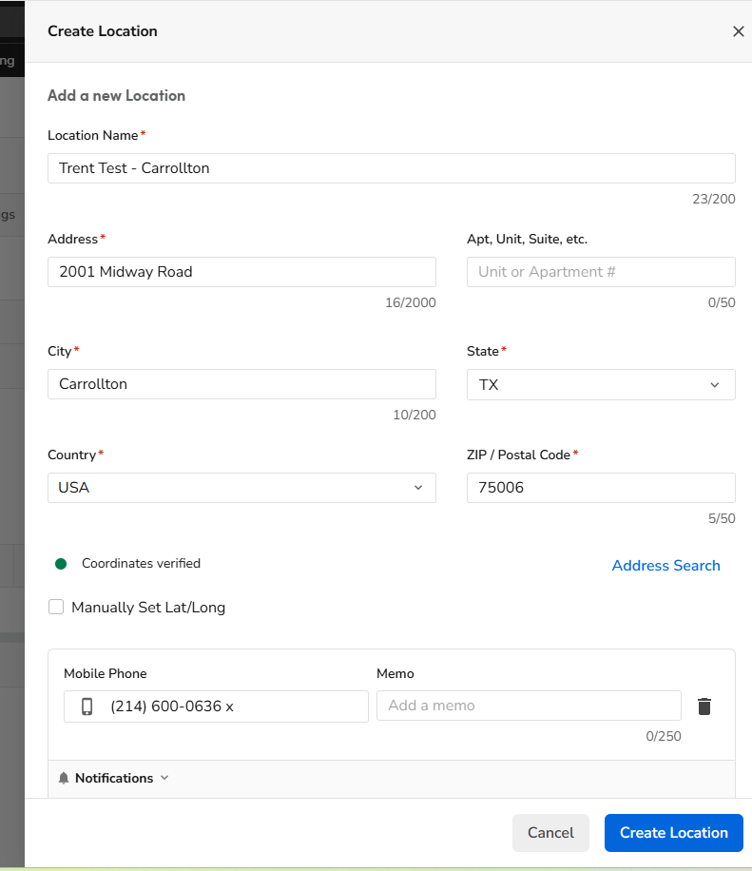  
  
  
21 -B.) Moving back to the* ***Service location*** *under the* ***auto glass*** *builder. Select Mobile - > Shop address you just created. Click add to estimate once saved  
  
  
22.) Moving forward with completing the estimate and adding our fuel charge. Click Service.  
  
23.) Search “Fuel” And click the Auto option  
  
  
24.) If your Cx is paying out of pocket, You are all done building the estimate! Give the customer a price and move onto the sale.   
25.) Once accepted Mark the estimate as sold and select yourself as “Sold by”  
26.) Click Actions - > collect payment. Enter the deposit amount and charge the cx accordingly  
  
  
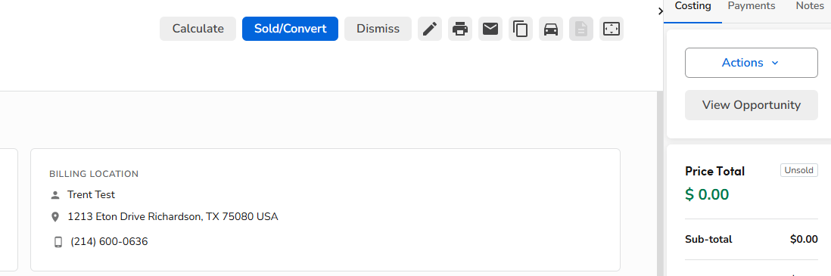  
  
  
  
  
  
  
  
27.) Click “Select all” and then “Book new Job”  
  
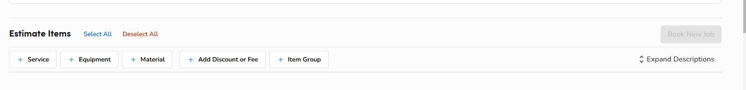  
  
28.) For scheduling please refer to “auto scheduling” In the slack channel  
29.) Fill in the required information   
30.) Be sure to unselect “send booking Confirmation”  
32.) Once booked, Text the cx asking for a photo of the glass from the outside of the vehicle for part verification.   
33.) If this was a same-day appointment make sure to add “same-day” tag and send a message in the “Auto same-day” slack  
  
  
  
Your job is now complete, Operations will take it from here!  
  
Auto – Insurance Playbook  
  
Setting up a cx that has not filed a claim yet:  
  
1.) Enter the insurance provider given by the Cx.  
2.) This will populate a phone # connecting you to a representative   
3.) Place the Cx on a brief hold while you reach out to insurance.* ***\*You are just letting the agent know that you have a policy holder on the line looking to get set up with the repairs for a windshield/door replacement through glass doctor of north Texas.\*****A screenshot of a computer
* *4.) Merge the calls and inform the cx that you are now on the line with Emily from All State. She is going to be helping you file this claim today.  
5.) The agent will then ask a few standard questions to the cx. *Often times mute yourself*   
6.) Be sure to enter the following information as the agent and Cx file the claim  
  
7.) If the Cx has already filed a claim through Glass Doctor, Search in click-up for the dispatch  
8.) This will be under “Lynx Dispatches” or ”Safelite Dispatches”  
9.) Click based on Cx filing date   
  
  
10.) Open the Pdf to ensure you have the right cx  
  
  
  
  
  
  
  
  
  
  
  
  
  
  
  
  
  
  
  
  
  
11.) Confirm with Cx name and enter information into St as you normally would  
  
12.) When Booking the job enter the dispatch number into the summary  
13.) Also include the deductible amount   
  
****\*Please note* The cx will only pay up to that deductible amount. We collect the reminder from the insurance company. (If cx deductible is $0 we do not collect a deposit)****14.) Collect the correct deposit amount and book the job as you normally would!  
  
Your job is now complete, Operations will take it from here!*

